**Cormac Buckley 15534413**

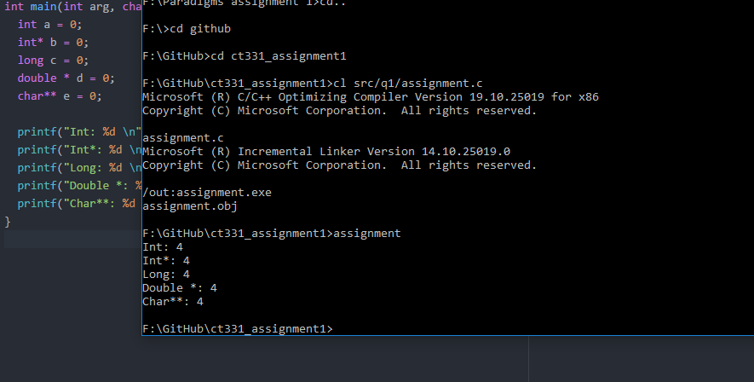

My results from this question gave a size of 4 bytes for every data type. This was unexpected and came about because of how the lab computer deals with these various data types